Case 1

Designer clothing marketer Guess, Incorporated has agreed to settle Federal Trade Commission charges that it didn’t use “reasonable or appropriate measures” to pre- vent personal consumer information from being accessed at its Web site, Guess.com. An investigation into the stolen personal data found that Guess failed to take measures to mitigate known weaknesses in its software supporting the Web site and these weaknesses were known to be commonly exploited by hackers. As part of the settlement agreement, Guess will implement comprehensive information security measures for Guess.com and affiliated sites. “Consumers have every right to expect that a business that says it’s keeping personal information secure is doing exactly that,” said Howard Beales, Director of the FTC’s Bureau of Consumer Protection. “It’s not just good business, it’s the law,” he said. Ironically, Guess.com had provided online statements that stated that customer’s personal information was secure and would be protected. The company’s online claims included, “This site has security measures in place to protect the loss, misuse, and alteration of information under our control,” and “All of your personal information, including your credit card information and sign-in password, are stored in an unreadable, encrypted format at all times.”
According to the FTC complaint, Guess did not maintain personal data in an encrypted form at all times, and the site had been vulnerable to a commonly known SQL injection attack since at least October 2000.
In February 2002, a visitor allegedly implemented such an attack and was able to view credit card information in clear text that was stored in Guess’s database. The Guess settlement prohibits the company from misrepresenting the extent to which it maintains and protects the security of personal information collected from or about consumers. It also requires that Guess establish and maintain a comprehensive information security program. In addition, Guess must have its security program certified as meeting or exceeding the standards in the consent order by an independent professional within a year, and every other year thereafter. An FTC Commission voted to accept the proposed consent agreement, but it has not been finalized into law. Copies of the complaint and consent agreement are available from the FTC’s Web site at http://www.ftc.gov.
SOURCE: Federal Trade Commission, http://www.ftc.gov/os/ 2003/06/guessanalysis.htm.

Questions
- Online banners are often used to enhance consumer confidence in making purchases online, but what implications are there if these online claims turn out to be false?
- How can a company ensure that it takes “reasonable or appropriate measures” to prevent personal consumer information from being accessed for illegitimate purposes?
- What implications does this case hold for persons involved in information security?

Case 2
The organization we consider in the case is a typical state university. We call it the Sunshine State University. Modern universities such as the Sunshine State University share most characteristics of medium-to-large businesses. They serve upwards of 20,000 demanding users, have thousands of employees, have budgets in excess of a billion dollars, and comply with various regulations. To meet the needs of all these constituencies, universities have all the business processes and IT systems found in a typical corporation such as HR, payroll, finance, and travel in addition to typical services such as email and calendar. Also, many research centers at universities act as custodians of sensitive personal data associated with research projects, creating information security needs comparable to the needs of most large businesses. In fact, it is not surprising to find state universities being some of the largest deployments of leading information technologies.

The organization
Sunshine State University is a State University. Like many state universities, about 30% of its funding comes from state taxes; another 30% comes from student tuition, and 30% from student financial aid (Figure. A).
The remaining 10% comes from an assortment of sources including research grants, alumni contributions, and revenue-generating academic programs such as executive education.
The university is trying to move towards a more elite profile by reducing its dependence on state taxes and tuition to about 20% each. The difference would be made up by increasing revenues from other sources to about 30% of the total budget from the current 10%.
The current enrolment at Sunshine State University is about 20,000 students. To serve these students, the university has about 700 faculty members (leading to a student–faculty ratio of about 29). There are also about 1,500 administrative support personnel performing functions such as academic counseling, scholarships, IT, finance, payroll, office managers, and so on.
To improve the student educational experience, Sunshine State University has begun to increase its focus on research opportunities for graduate and undergraduate students. At the current time, this emphasis is led by the colleges of Engineering and Medicine. Recently hired faculty members in both these colleges have strong records of attracting research funding from sources such as the National Science Foundation and the National Institutes of Health. While these projects create great opportunities for students to earn scholarships while working on research projects, university administrators have been advised by their colleagues that the university should upgrade its systems for handling the data created by these projects. Universities have been taken to court for violating the privacy of research subjects and students.

The organization structure
An extract from the organization structure of the university is shown in Figure A. Provost is responsible for all Academic Affairs on the campus. The Chief Operating Officer is responsible for all business and finance activities on campus. The General Counsel manages legal affairs and compliance. Students in the College of Medicine do their residency in the local Downtown Hospital. The hospital itself is part of a larger conglomerate and has its own IT support personnel. A major research project initiated by college faculty has enrolled 4,000 newborn children to study the medical impacts of interactions between environmental factors and genetic structures. The study will follow these children for up to 15 years. The college maintains its own IT services that primarily consist of providing email services and shared document storage.
The College of Fine Arts is known for its School of Art, graduating several well-known graphic artists. While the location of the university is not home to a major movie studio, some of its recent graduates have leveraged the video capabilities of DSLR cameras to gain success as movie directors in the indie movie circuit.

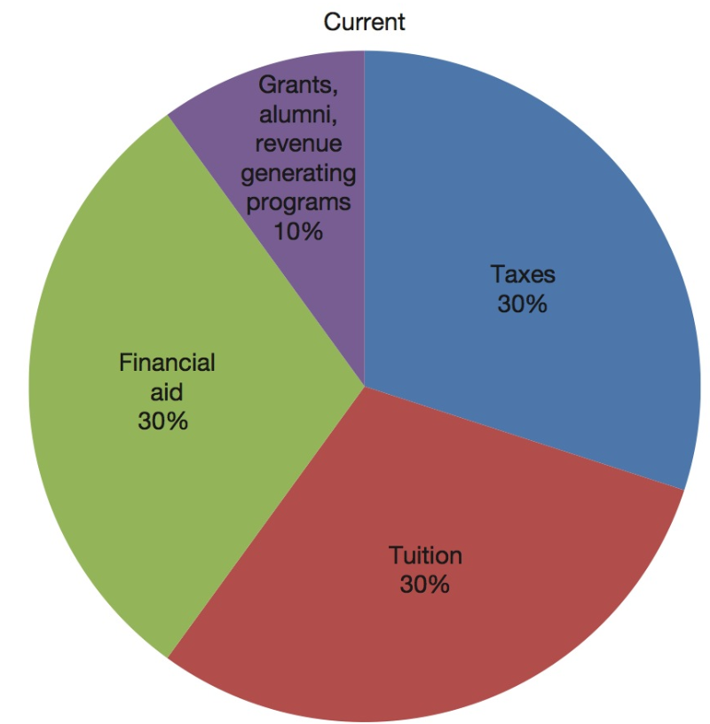 | 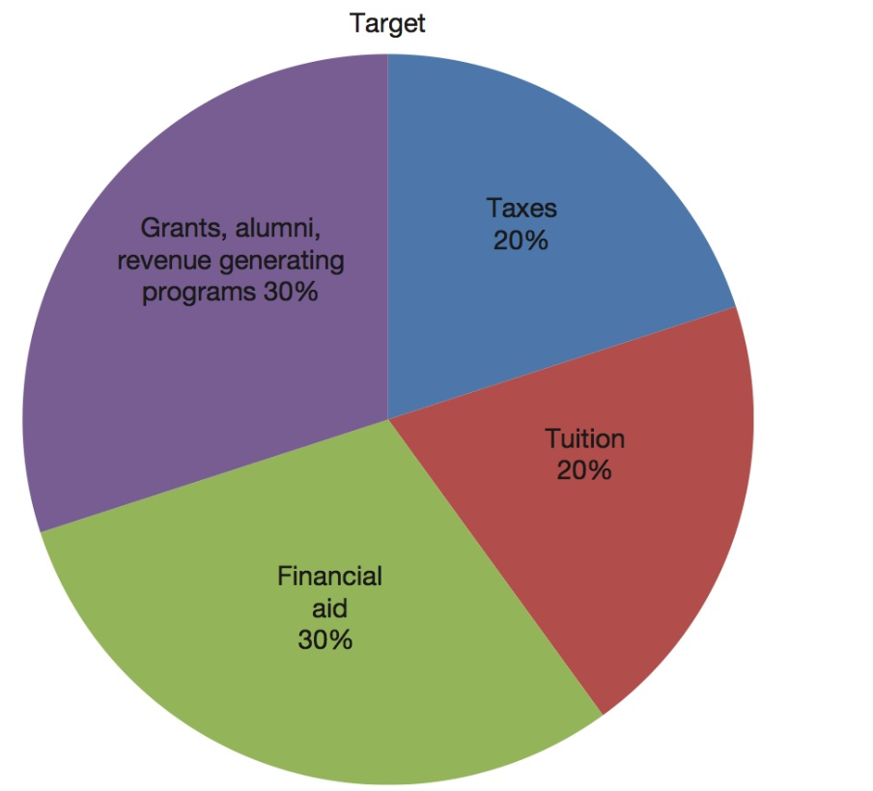
Current | Target
Sunshine State University funding sources
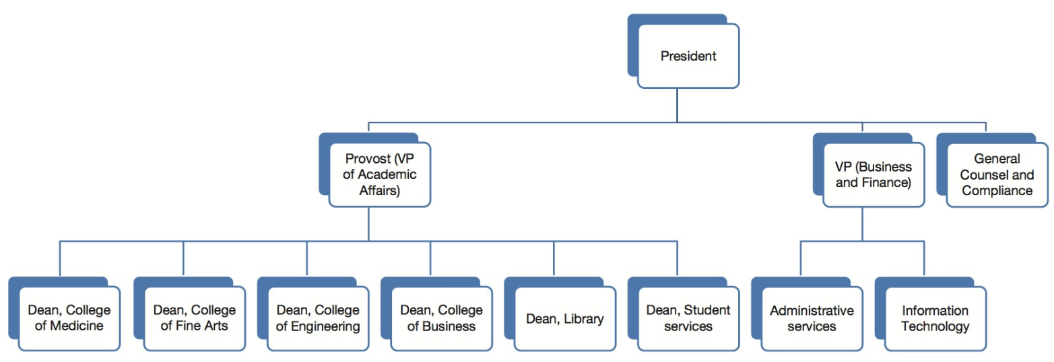
Organizational Chart of Sunshine University

The School of Engineering is beginning to gain traction with funding agencies, attracting some seed funding from the US Department of Defense for developing sensors and associated applications for battlefield deployment. In addition to its regular teaching and research activities, the College of Business supports local minority businesses in the community by providing a business incubator, where small disadvantaged business (SDBs) can utilize IT resources and mentoring from local faculty on writing business proposals, marketing, distribution,

The Library is small but very active. In addition to the traditional library services, the library offers undergraduate and graduate degrees in library sciences. The library is actively looking for partnerships with vendors and publishers in order to migrate to an e-textbook model. They are also leading an effort to combine collections with other state and local government libraries and improve their interlibrary loan systems.

Student Services supports students by attending to their non-course-related needs such as student loans, housing, and code of ethics, student government, and other student organizations. The business and finance services on campus are largely centralized. The administrative services component handles purchasing, physical plant, grounds maintenance, and University Police. They also deal with payroll, hiring procedures, and benefits.
Information Technology deals with all enterprise-wide IT efforts, including the Enterprise Business Systems. The Student Information System, HR systems, and payroll and financial systems are operated centrally by IT. Some ancillary IT services are operated as a mix of centralized services and local support. These services include desktop support and management, file share management, print management, account provisioning, and server management. To save costs, the management of some of these services is led by non-tenured faculty members whose primary responsibility is to teach classes.
Generally speaking, technical staff is overworked, under paid, but is well-trained and qualified. They do their best to meet student expectations on a limited budget. The information security department is part of IT.

Questions:
- What are some of the ways in which weaknesses in information security can potentially cause embarrassment or financial losses to the university?
- List three items of information stored in the university’s information systems for which the university is expected to maintain confidentiality. What are some of the ways in which the confidentiality of each of these items may be compromised?
- List three items of information stored in the university’s information systems for which the university is expected to maintain integrity? What are some of the ways in which the integrity of these items may be compromised?
- List three items of information stored in the university’s information systems for which the university is expected to maintain availability? What are some of the ways in which the availability of these items may be compromised?

